Inclusive Agribusiness Guidance Note

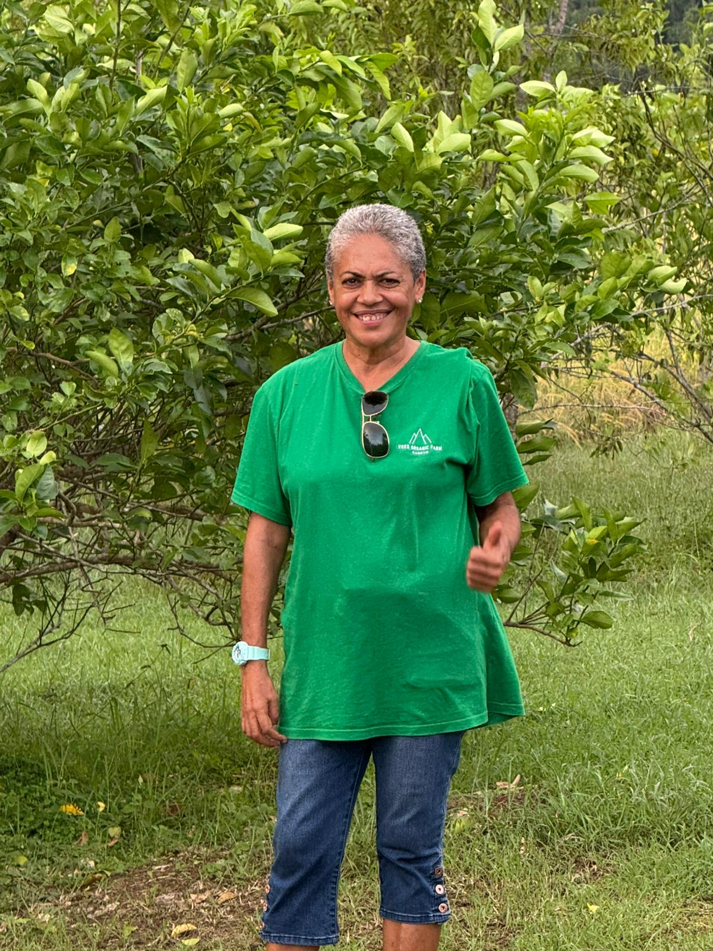
Photo: Vitila Vuniwaqa of Vee’s Organic Farm standing in front of a lime tree on her 12 Acre farm in Sabeto, Fiji. Source: Ana Macanawai
Inclusive Agribusiness Guidance Note

Client: Department of Foreign Affairs and Trade

Prepared by
DT Global Asia Pacific
Level 14, 501 Swanston Street,
Melbourne VIC 3000, Australia
+61 8 8317 4300
www.dt-global.com
ABN 23 006 170 869

2025

Job No.: 70000191 (2022–2026)

© DT Global Asia Pacific Pty Limited. All rights reserved.

No use of the contents, concepts, designs, drawings, specifications, plans etc. included in this report is permitted unless and until they are the subject of a written contract between DT Global Australia Pty Limited (DT Global) and the addressee of this report. DT Global accepts no liability of any kind for any unauthorised use of the contents of this report and DT Global reserves the right to seek compensation for any such unauthorised use.

Document Delivery

DT Global provides this document in either printed format, electronic format or both. DT Global considers the printed version to be binding. The electronic format is provided for the client’s convenience and DT Global requests that the client ensures the integrity of this electronic information is maintained. Storage of this electronic information should at a minimum comply with the requirements of the Electronic Transactions Act 2002.
Contents
Acronyms 4
Acknowledgements 5
How this Document is Organised 5
Introduction and Purpose 7
Key Concepts 8
1. What is Agribusiness 8
2. What is Disability 8
Sidebar – ‘Nothing without us’, Working with OPDs: The Smartest Way to Get Disability Inclusion and Equity Right 9
3. What is Inclusive Agribusiness 10
4. The six Preconditions for Inclusion 11
Story – Growing with Support: Peniasi’s Story of Inclusive Farming and Government Partnership in Fiji 13
Story – Fiji: Tailored Support Unlocks Agribusiness Potential at Home 14
5. Reasonable Accommodations 14
Business Case for Inclusion 15
Story – Tonga: Access to Tools Boost Productivity and Progress 16
Story – Farming with Purpose: How Inclusion, Innovation, and Value Addition Grow Local Economies 17
Sidebar – Inclusive Agribusiness: Good for Communities, Strong for Business—and Recognised by ESG and Benefit Corporation Standards 18
Barriers to Inclusion in Agribusiness 18
Sidebar: Inclusive Finance in Agribusiness 20
Sidebar – Government’s Role: Creating the Conditions for Inclusive Agribusiness 23
Become an Employer of Choice for People with disabilities 24
Story – Vanuatu: Building Inclusion into the Business Model from Day One 27
Inclusion across the value chain 29
Story – Samoa: Leading from the Land, A Farmer’s Vision for Inclusive Agribusiness 29
Sidebar - Important Note on Adapted Tools and Environments 30
Conclusion 35
Annex 1: Preconditions for Inclusion - A Checklist for Agribusiness to Reflect and Act 36
Annex 2: Practical Examples of Preconditions for Inclusion in Action 40

Acronyms
Acronym | Expansion
ADB | Asian Development Bank
AT | Assistive Technology
B Corp | Benefit Corporation
CBID | Community-Based Inclusive Development
CRPD | Convention on the Rights of Persons with Disabilities
DFAT | Department of Foreign Affairs and Trade (Government of Australia)
ESG | Environmental, Social and Governance
GEDSI | Gender Equality, Disability, and Social Inclusion
ILO | International Labour Organization
MFAT | Ministry of Foreign Affairs and Trade (Government of New Zealand)
NGO | Non-Governmental Organisation
NCDs | Non-Communicable Diseases
OPD | Organisation of Persons with Disabilities
OPDs | Organisations of Persons with Disabilities
PDF | Pacific Disability Forum
PHAMA Plus | Pacific Horticultural and Agricultural Market Access Plus Program
PWAF | Pacific Week of Agriculture and Forestry
SDG | Sustainable Development Goal
SDGs | Sustainable Development Goals
UN | United Nations

Acknowledgements
The Strategic Development Group Team – Christina L. Parasyn, Setareki S. Macanawai, Katiya Sakala and Erin Corvisy – sincerely acknowledges the PHAMA Plus program and the Governments of Australia and New Zealand for their commitment to the rights, inclusion, and equity of people with disabilities in the agricultural sector across the Pacific.
We extend deep appreciation to the Inclusive Agribusiness Reference Group, whose strategic oversight and contextual advice helped shape this guidance note. Their guidance ensured that the process and final content remained relevant, accessible, and grounded in the realities of Pacific communities.
We are especially grateful to the farmers with disabilities, Organisations of Persons with Disabilities (OPDs), agribusinesses, PHAMA Plus staff and development partners across Fiji, Samoa, Solomon Islands, Tonga, Vanuatu and regional networks who generously contributed their time, experiences, and insights. Their stories and knowledge are the foundation of this document.
Vinaka vakalevu, malo ’aupito, fa’afetai lava, tangkyu tumas, and tagio tumas, thank you to all who made this guidance note possible.

How this Document is Organised
This guidance note is designed to be practical, easy to navigate, and accessible to a wide range of users, including persons using screen readers or other assistive technologies.
The document includes the following types of content:
- Main Sections
Each main section of the guidance note is clearly marked with headings using Heading Style 1 or Heading Style 2. These sections provide core guidance on what is meant by inclusive agribusiness, including key terms, why it matters, what we learnt from consultations, and what actions can be taken to become an agribusiness of choice including in employment and across the value chain.
- Sidebars – Practical Tips and Guidance
Throughout the document, you will find sidebars that offer practical tips, summaries, or checklists. These are labelled using clear bolded headings like: Sidebar – Tips for Becoming an Employer of Choice. These headings use Sidebar Heading Style.
In this accessible version, these sidebars are placed in a one-cell table to help them stand out visually without compromising screen reader accessibility. The table has only one row and one column, contains no header, and is not used for layout. This structure helps both low vision users and readers with cognitive disabilities to navigate the content more easily.
- Stories – Real Experiences from the Pacific
The guidance note features real stories shared by farmers with disabilities, organisations of persons with disabilities (OPDs), and agribusinesses across the Pacific. These stories bring the guidance to life and highlight how inclusion is working in practice. Each story is introduced with a bolded heading like: Story – Tonga: Building Inclusive Supply Chains. These headings use Story Heading style.
Stories also appear in a one-cell table to support visual clarity for readers, while remaining screen-reader compatible.
Tip for screen reader users:
You can use your screen reader’s heading navigation features to move quickly between sections, sidebars, and stories. Headings are marked using Word’s built-in styles (Heading 1, 2) for consistency.
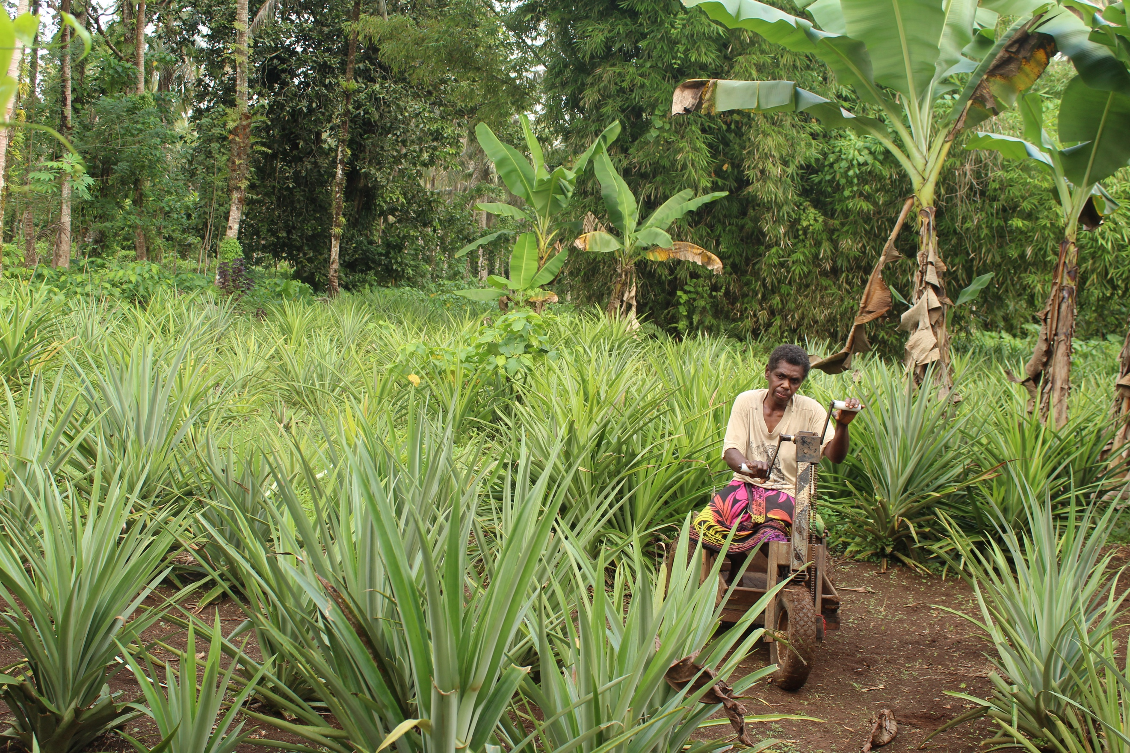
Photo: Mrs. Prazchet Sivot on her Pineapple farm in Santo Island, Vanuatu.
Source: Vanuatu Disability Promotion and Advocacy Association.

Introduction and Purpose
“Our bodies work differently, but our determination grows the same crops.” Farmer, Tonga
Inclusive agribusiness enables people with disabilities to participate in, contribute to, lead, and thrive across the agricultural sector. In the Pacific, people with disabilities are already active as farmers, producers, marketers, innovators, and leaders. However, barriers ranging from inaccessible tools and transport to stigma and exclusion continue to limit their full participation.
The Pacific Horticultural and Agricultural Market Access Plus Program (PHAMA Plus) is a multi-country agricultural market systems development and export market access program operating in nine Pacific Island countries (Cook Islands, Fiji, Kiribati, Niue, Samoa, Solomon Islands, Tonga, Tuvalu and Vanuatu).
PHAMA Plus is funded by the Governments of Australia (DFAT) and New Zealand (MFAT). PHAMA Plus works with a wide range of community, public and private sector partners, including agribusinesses. A core priority for PHAMA Plus is to support the development of inclusive market systems, contributing to inclusive growth for Pacific farming households and communities.
In April 2025, PHAMA Plus engaged Strategic Development Group to develop this Inclusive Agribusiness Guidance Note.
This guidance note provides practical actions that can be taken by agribusinesses, OPDs, and farmers with disabilities to create inclusive systems that benefit everyone. It shares insights gathered from over 100 stakeholders in five (5) Pacific Island countries, including Fiji, Samoa, Solomon Islands, Tonga and Vanuatu. The consultation process captured rich diversity across geography, age, gender, disability type, stakeholder role, and agricultural production. A breakdown of registered participants is provided in the footnote.
This guidance note is grounded in the Pacific context. It includes real stories, lessons, and tools to support immediate and longer term action.
While the focus of this guidance note was intentionally on the agribusinesses, OPDs and farmers with disabilities, the content and recommended actions shared in this document are relevant and apply to all stakeholders including governments, civil society, private sector and development partners alike.

Key Concepts

What is Agribusiness
In the context of PHAMA Plus, agribusiness refers to the broader business activities involved in the production, processing, and distribution of agricultural products, including horticulture.
Agribusinesses can play multiple roles in inclusion. This note highlights how these roles can be activated through partnerships and practical action.

What is Disability
The United Nations Convention on the Rights of Persons with Disabilities (CRPD) Article 2 states that:
‘Persons with disabilities include those who have long-term physical, mental, intellectual or sensory impairments which in interaction with various barriers may hinder their full and effective participation in society on an equal basis with others.’
Disability is part of human diversity. People with disabilities are diverse in gender, age, location, culture, and type of impairment. This diversity shapes their experience of farming, employment, exclusion, barriers and opportunity, and must be central to how inclusive agribusiness is approached.
This human diversity means that solutions to address these barriers and disadvantages are also diverse.
Disability inclusion means working with people with disabilities and their representative organisations to identify and remove barriers, value diverse capabilities, innovate solutions and ensure full access to economic and social opportunities.
“Don’t underestimate people with disabilities. Focus on what we can do and not what we can’t” - Unatolo F Halafihi, Naunau o e Alamaite Tonga Association (NATA), Tonga
This note shares the multiple barriers experienced by people with disabilities in the agriculture sector. It also highlights the partnerships and practical actions that can ensure their meaningful and effective participation, contribution and leadership as farmers, agribusinesses, employees and employers.
Sidebar – ‘Nothing without us’, Working with OPDs: The Smartest Way to Get Disability Inclusion and Equity Right
Organisations of Persons with Disabilities (OPDs) are representative organisations or groups of people with disabilities. OPDs are led by and for people with disabilities. People with disabilities are well represented across the organisation and comprise the majority of their staff, board and volunteers. They are mandated by the CRPD to advocate for the rights and interests of people with disabilities.
OPDs are not just stakeholders or beneficiaries. They are essential partners – the backbone of success in inclusive agribusiness. Here’s why:
- OPDs bring lived experience, community trust, and the expertise needed to ensure inclusion works in practice—not just on paper.
- From design to delivery and monitoring, OPDs know what works. They co-create training, advise on accessibility, can connect you to diverse farmers, and ensure solutions are grounded in real community needs.
- OPDs have unmatched reach and representation. They can connect you to the full diversity of the disability community—women, youth, people in rural areas, and those with different types of disabilities and disadvantage.
- Trained on the CRPD, OPDs can guide your work in line with the CRPD as well as national, regional and international frameworks.
But too often, OPDs are invited late – or not at all.
“Engage us from the beginning to the end - not just in the middle when you need data.”
“Formalise collaboration and shared data hubs to track and support farmers with disabilities.”
(OPD members across the Pacific)
Practical action: Collaborate with OPDs – a necessary first step for agribusinesses. Contact an OPD in your country today! A list of Pacific Disability Forum’s (PDF) OPD members can be found on the PDF website.

What is Inclusive Agribusiness
Inclusive agribusiness refers to policies, systems and practices that ensure people with disabilities can engage equitably and meaningfully across all aspects of the agriculture sector.
Inclusive agribusiness values the contributions and aspirations of people with disabilities and promotes rights, dignity, economic empowerment, and sustainability.
It recognises that people with disabilities and agribusinesses alike can be employers, employees, suppliers, business owners, trainers, buyers, advocates, managers and leaders, innovators, financiers, ecosystem connectors and family-based enterprises.
Inclusive agribusiness includes formal and informal contributions across the value chain, the household and the business. In family-owned businesses, it also enhances family cohesion and strengthens customer relationships.
Story – Stronger Together: How Inclusive Hiring Strengthens Families, Business, and Community
In our agribusiness, inclusion starts at home. My daughter, who has a disability, plays an important role in labelling products and helping sell our non-export produce. The various roles she plays are deeply meaningful and valuable to our business — they strengthen our family teamwork, she monitors and helps manage our stock, and she supports us to meet quality standards.
Her involvement has also created a ripple effect. Customers and colleagues recognise the value of her contribution, and this has helped foster a more respectful, inclusive, and thoughtful work environment. It’s not just improved how we work together — it’s also deepened our relationship with the wider community.
We’ve faced challenges, too. My daughter is shy and finds it difficult to interact with people she doesn’t know. But with the right support — training, guidance on communication, and programs that connect us with others on similar journeys — we believe we can help her grow and include more people with disabilities in future. For us, inclusion isn’t a checkbox — it’s something that makes our business, and our family, stronger.
Shared by, Sala Sagato Tuiafiso, Saints Agriculture and Export, Samoa.

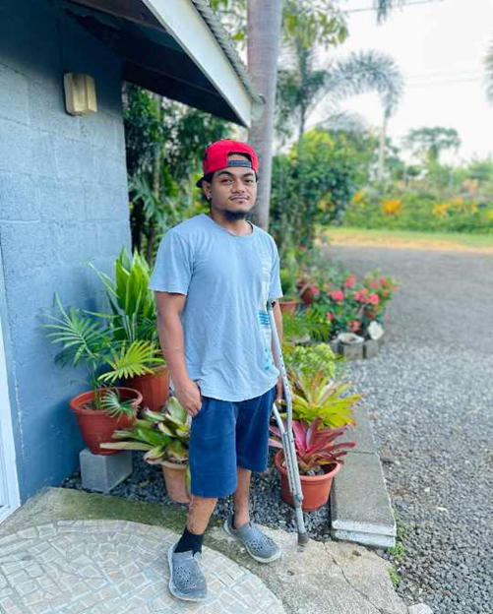

Photo: Nofo Stanley, of Flonior’s Tropical Plants & Elei (PHAMA Plus partner), standing outside his family’s ornamentals business in Apia, Samoa. Source: PHAMA Plus.

The six Preconditions for Inclusion
Inclusion doesn't happen by accident. It requires structural, systemic, attitudinal and social change.
This guidance note uses the Pacific Disability Forum’s Precondition for Inclusion Framework as the main guiding framework to support inclusion of people with disability in the agricultural sector. The 2050 Strategy for the Blue Pacific Continent and its implementation plan highlight the importance of the preconditions for inclusion in accelerating the policy frameworks, systems, institutional strengthening, financing and capabilities that drive people centred development, inclusion and equity in the Pacific.
The preconditions for inclusion are a set of six key interconnected and mutually reinforcing foundations that are essential to create an enabling environment for the inclusion of people with disabilities in all aspects of society. The framework’s purpose is to enable all stakeholders to identify and address the core systemic barriers experienced by people with disabilities daily.
‘The preconditions are more than a checklist; they are an interwoven framework, each reinforcing the others to unlock participation and realise rights.’ Pacific Disability Forum
The six preconditions and the explanation of each precondition in relation to ensuring farming and agribusiness are inclusive follows:
- Non-Discrimination: Removing legal, policy, social, and attitudinal barriers that exclude people with disabilities from opportunities. This includes reasonable accommodation, inclusive hiring, and representation.
- Accessibility: Ensuring environments, information, transport, and communications are accessible. Accessibility is the foundation that enables participation in agribusiness and community life.
- Assistive Technology: Providing access to essential assistive products and services that support independence, mobility, communication, and productivity in farming and business.
- Support Services: Ensuring availability of personal assistance, peer support, sign language interpretation, and other human supports necessary for people with disabilities to fully engage in farming, agribusiness, economic and community life.
- Community-Based Inclusive Development (CBID): Mobilising community resources and networks to reach and support people with disabilities in rural and remote areas, ensuring inclusive development that leaves no one behind.
- Social Protection: Addressing the additional costs of disability through targeted allowances, disaster-responsive payments, and inclusive benefit schemes that support participation and resilience.
This framework underpins the checklist and solutions explored in this note. Refer Annex 1 for the tool ‘Preconditions for Inclusion: A Checklist for Agribusinesses to Reflect and Act’ to explore how you can become an inclusive agribusiness. Refer Annex 2 for ‘Practical Examples of Preconditions for Inclusion in Action’.
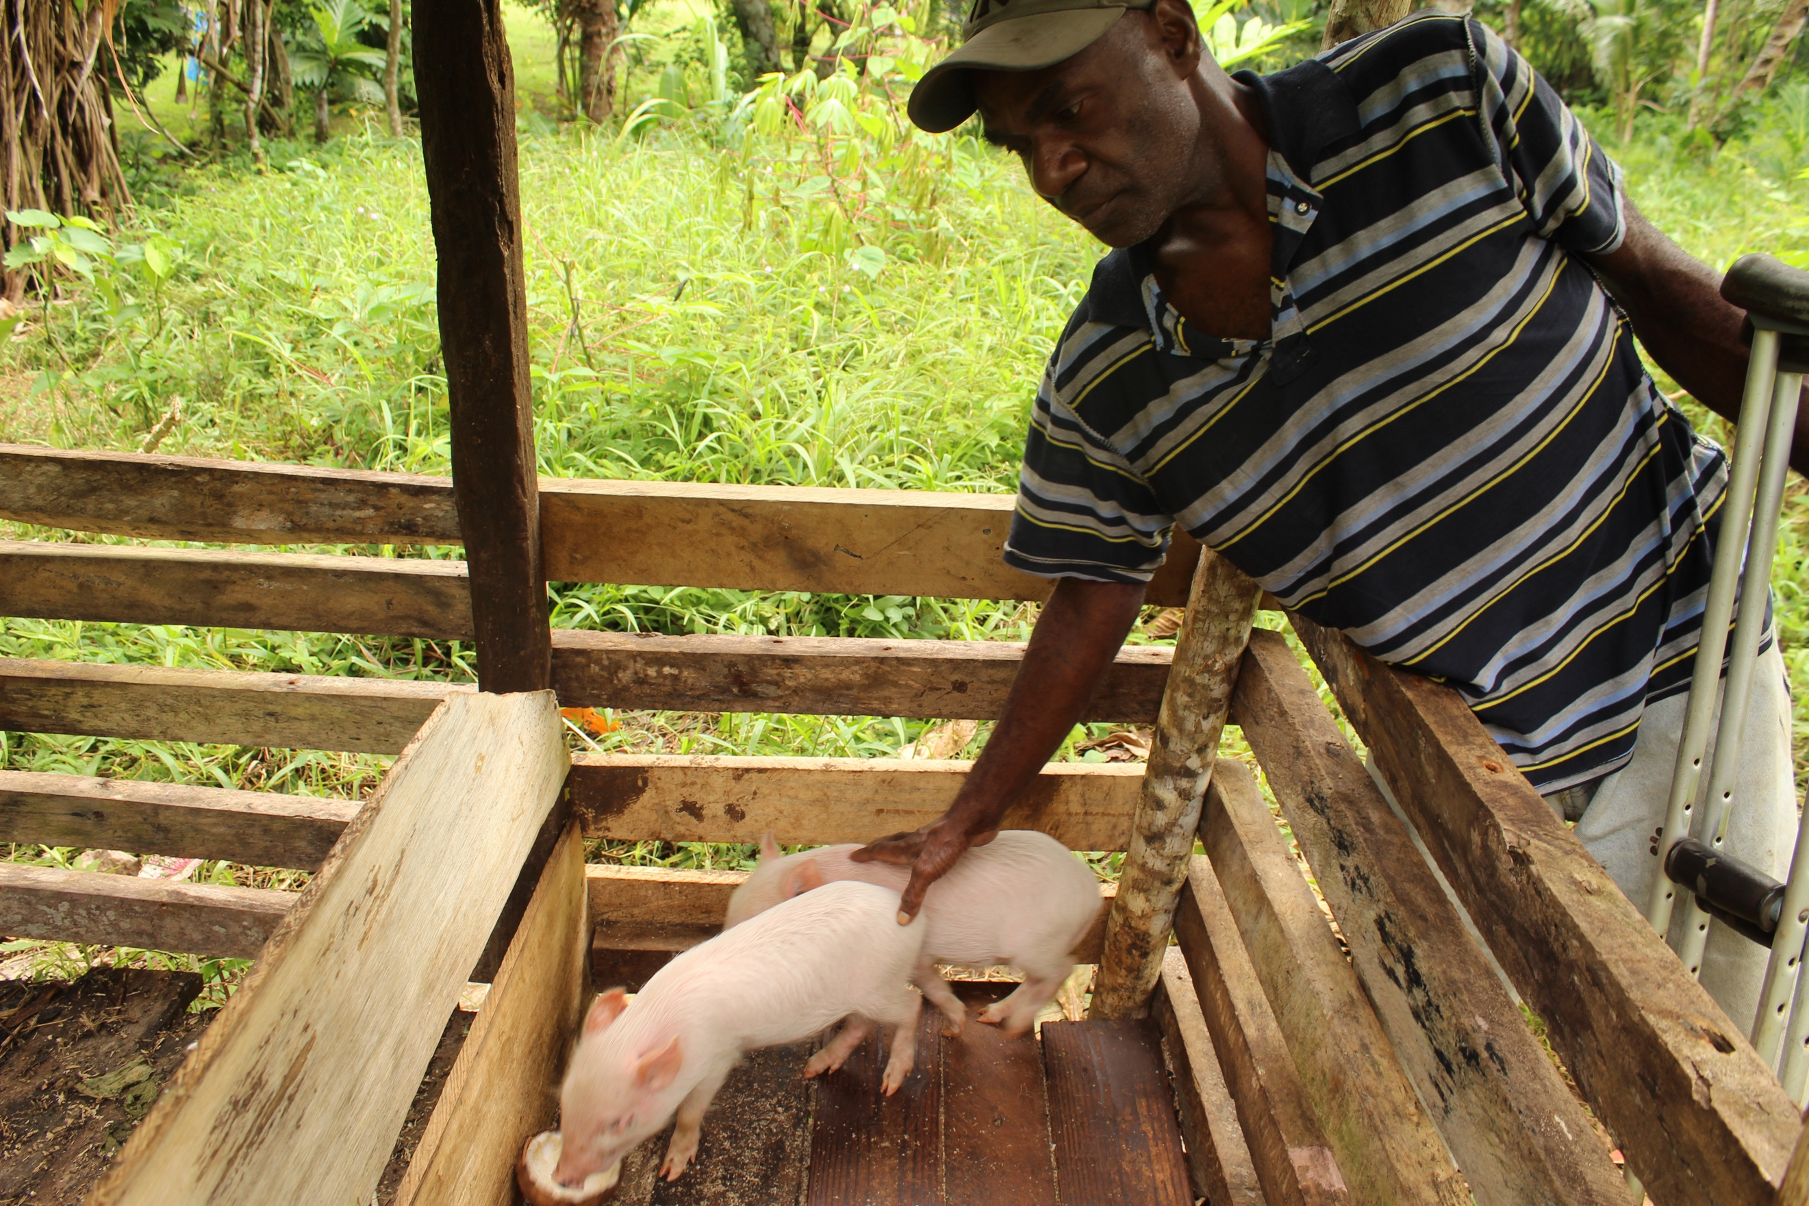
Photo: Mr Hosea Langi, a Pig and Kava Farmer standing by his raised pig feeding pen feeding his pigs, Vanuatu. Source: Vanuatu Disability Promotion and Advocacy Association.

Story – Growing with Support: Peniasi’s Story of Inclusive Farming and Government Partnership in Fiji
My name is Peniasi. I live in a small village in Fiji on the other side of a river, with no road access. I’m a wheelchair user and have a physical disability, having lost both my legs above the knee. I started farming in 2022, but the labour was hard and I became unwell. In 2023, a friend introduced me to greenhouse farming. He gave me some tools and advice, and that changed everything.
Now I grow tomatoes, lettuce, and cucumbers in my greenhouse, and dalo out in the open. I also raise pigs and cattle using land owned by my mother. I walk on what’s left of my legs when I farm. I don’t use my wheelchair in the field. I do the planting myself, and only my wife and son help me.
In 2024, agricultural officers visited and saw how I was manually filling a tank with water from a creek. They returned with support — piping materials and, later, a large water pump. That water system now supports my greenhouse during the dry season. They also invited me to the agricultural show, where I was awarded Fiji’s Disabled Farmer of the Year and received FJ$3,000.
During rainy season, I start my seedlings inside my house with soft paper and rainwater, then move them to pots, and later to the greenhouse. I sell my vegetables in Nausori town, dalo to the agro market, and cattle to the local abattoir.
When I heard about agribusiness from the agricultural officers it really opened my eyes. The partnership with Government is important. It not only provides me with the support I need now, but as I have a lot of land, it can help me to extend my farm, increase products and yield.
I want to be a big farmer in my community. I want access to big farming machines once the road to my village is built, employ youth in my village, and one day export to overseas markets.
Story shared by Peniasi Dobui, Fiji.

Story – Fiji: Tailored Support Unlocks Agribusiness Potential at Home
In Fiji, the Psychiatric Survivors Association (PSA), an organisation representing people with psychosocial disabilities, is showing that when training, tools, and support are adapted to meet the needs of persons with psychosocial disabilities, inclusive agribusiness becomes not only possible, but powerful.
After COVID-19, PSA conducted a situation analysis which revealed that members had long experienced exclusion from family, community, and economic life. The exclusion was deeply linked to being seen as “patients” rather than contributors to family, community and the national economy. In many communities, status depends on what you can contribute. Without opportunities to engage in income-generating activities, stigma deepened.
PSA responded with a new approach – an economic empowerment initiative built from the ground up by and for people with psychosocial disabilities. With support from carers, local leaders, and a peer advisor with lived experience, PSA co-designed tailored training, drawing on the ILO’s Start Your Own Business model. It involved inclusive business planning, hands-on skills training, and simple tools for visual communication.
More than 30 members have now received grants and established home-based enterprises from poultry and crab farming to vegetable growing and screen printing. One participant reflected that this was the first time they felt truly seen. “They wanted the activities to continue every day. It gave them back a sense of who they are.” Said a PSA staff member.
With continued peer support and mentorship, these businesses are changing not just incomes, but how communities view the role and value of persons with psychosocial disabilities in local economies.

Reasonable Accommodations
CRPD Article 2, states that reasonable accommodation is
‘…necessary and appropriate modification and adjustments not imposing a disproportionate or undue burden, where needed in a particular case, to ensure to persons with disabilities the enjoyment or exercise on an equal basis with others of all human rights and fundamental freedoms.’
It is support and practical actions provided for individuals with disabilities to make sure they can effectively and meaningfully participate in each situation, like everyone else.
The solution or adaptation is for individuals, so discussing the accommodation needed must happen with the person with disabilities. It might include sign language interpreters, language interpreters, information in electronic copy, large print or braille, adjusted work hours, access to a support person to help make complex training simpler, a sighted guide, raised garden beds, adapted tools, accessible greenhouse, portable ramps, information represented in picture format, in-field coaching and mentoring.
OPDs are a valuable source of information and support in understanding what reasonable accommodations can be made and where to source them.

Business Case for Inclusion
Inclusive agribusiness is not only a human right, it makes economic sense. During the development of this guidance note, consultations with Pacific stakeholders and desk research identified the top five (5) reasons why inclusive agribusiness matters in the Pacific. These include:

1. It Tackles Labour Gaps and Enhances Productivity
- Labour shortages, especially in rural and seasonal agriculture, are a persistent challenge across the region.
- Disability inclusion enables access to an untapped, motivated workforce, including farmers with disabilities who are already active in subsistence and smallholder agriculture.
- Higher proportions of people with disabilities turn to self-employment due to barriers in the formal labour market, meaning many are already innovating to overcome access barriers.
- Consultations revealed strong family and community-based labour systems supporting farmers with disabilities, enabling shared productivity models.

2. It Boosts Household Resilience and Food Security
- Inclusive farming practices contribute to daily food security, income generation, and support for education and health costs within households.
- It increases economic resilience by diversifying income sources, especially important for rural households prone to shocks.
- Growing food at home supports nutrition and wellbeing, and regular activity helps reduce the risk of non-communicable diseases (NCDs)—a major health issue in the Pacific.
“Selling from home has helped me support my family—and people know me now as a vegetable farmer.” – Farmer, Solomon Islands

Story – Tonga: Access to Tools Boost Productivity and Progress
A 45-year-old farmer from Tonga, who had a left arm amputation in an accident in 1999, has sustained his household for over two decades through root crop cultivation and pig rearing. Despite limited resources, he continues to support his wife and three children through subsistence and small-scale market farming.
Managing his crops without a weed killer machine has required him to pay other farmers for spraying, reducing his earnings and slowing down crop cycles. Manual weeding is not feasible due to his disability, and borrowing tools from others is not always reliable. These limitations have constrained his ability to increase yield and income.
He also finds it hard to afford quality pig feed, which affects the growth and market value of his livestock. His goal is to improve efficiency by acquiring a weed killer machine, which would reduce costs, increase planting cycles, and boost crop yields by an estimated 30–50%. Additional income would be reinvested into pig feed and farm inputs.
Access to appropriate tools and inputs would increase his productivity, support his family’s financial stability, and contribute to Tonga’s agricultural output through expanded local market sales and improved livestock supply.

3. It Drives Inclusive Economic Growth and Market Participation
- Farmers with disabilities are active contributors to local markets and informal economies, especially through small-scale, community-based sales.
- Inclusion increases market reach and value chain participation, tapping into underrepresented talent and customer bases.
- With the right support, informal channels can scale into formal micro or small enterprises, improving livelihoods and long-term sustainability.
“I want to supply eggs to all Tongan stores and help bring prices down.” Kelekolio Halafihi Young Deaf Farmer, Tonga

Story – Farming with Purpose: How Inclusion, Innovation, and Value Addition Grow Local Economies
After 17 years as a flight attendant and a national surfing representative, everything changed when I experienced a stroke in 2010. Relearning how to walk and speak again, I made a decision that reshaped my life. I bought a 12-acre farm in Wailoko, outside Nadi, and began Vee’s Organic Farm.
Over time, with the help of my family, friends and the farming community, I expanded from farming to value-addition and agro-tourism. I grow cassava, dalo, lemongrass, bananas, avocado, and more. What I love most is turning these into new products. From my kitchen, I now make lemongrass body balm, mosquito repellent, and lip balm, all sold to local guests and returning customers. I am committed to inclusive, women-led trade and I partner with women from Gau, who supply virgin coconut oil.
Despite limited government follow-through and challenges like a crumbling community bridge, I keep innovating. I now offer hiking tours, guest stays, and community-led planting into what I offer. For me, agribusiness is not just about profit. Its about healing, creativity, and inclusion. There’s potential in everything we grow. Cassava can be flour and chips. Lemongrass is not just for tea, it’s health and scent and livelihood.
My vision is to have a factory on the farm to make my body essential oils, build more guest bures, and eventually add a zipline for visitors. I also want to employ people with disabilities in my farm and factory.
I want to show that agribusiness can be a place for healing, employment, and creativity. There’s more than one way to grow something and more than one way to make it thrive.
Story shared by Vitila Vuniwaqa, Vee’s Organic Farm, Fiji.

4. It Aligns with ESG, B Corp, GEDSI, and Localisation Commitments
- Disability inclusion is a core pillar of Environmental, Social, and Governance (ESG) standards, B Corp Certification, Gender Equality, Disability and Social Inclusion (GEDSI) strategies, and localisation agendas.
- Inclusive agribusiness supports commitments under the CRPD, Pacific Framework on the Rights of Persons with Disabilities, 2050 Strategy for the Blue Pacific Continent, Jakarta Declaration on the Asian and Pacific Decade of Persons with Disabilities and the UN Sustainable Development Goals (SDGs).
- Businesses that act on inclusion are better positioned for responsible investment, funding opportunities, and stakeholder partnerships.
Sidebar – Inclusive Agribusiness: Good for Communities, Strong for Business—and Recognised by ESG and Benefit Corporation Standards
Inclusive agribusiness isn’t just good practice, it’s smart ESG and B Corp-aligned business.
- Environmental (E): Enables people with disabilities to lead inclusive, climate-smart practices—contributing to sustainable agriculture and innovative local solutions.
- Social (S): Promotes equity, participation, and decent work by including people with disabilities across the value chain and in the business. Aligns with B Corp “Workers” and “Community” metrics on diversity, fair employment, and underrepresented groups.
- Governance (G): Embeds transparency and accountability through disability-disaggregated data, inclusive hiring policies, and partnerships with OPDs. Reflects strong governance and stakeholder engagement, ensuring representation in decision making, in line with key B Corp principles.
Inclusive agribusiness helps businesses stand out in ESG reporting, B Corp certification, and responsible sourcing schemes. It demonstrates commitment to values, community, and long-term impact.

5. It Creates Stronger, More Sustainable Partnerships
- OPDs are trusted and representative partners. They bring legitimacy, community reach, and insight into what works.
- Co-design with OPDs ensures accessibility, cultural relevance, and shared ownership of agribusiness interventions.
- OPDs that informed this guidance note shared that they are increasingly serving as members of agricultural boards, helping to design and deliver inclusive training, and supporting market access for farmers with disabilities.
“OPDs are not service providers—they are the voice of persons with disabilities. Contact them first.” – Vanuatu Disability Promotion & Advocacy Association (OPD)

Barriers to Inclusion in Agribusiness
“If I’m treated like a farmer, not a burden, then I’ll show I can succeed.” – Farmer, Solomon Islands
Despite opportunity, key barriers remain. Barriers to disability inclusion are commonly grouped as policy and institutional, physical and environmental, information and communication, and attitudinal barriers.
Drawing on the above barriers and the preconditions for inclusion as a framework, consultations revealed the barriers to Inclusive Agribusiness in the Pacific. While the barriers below focus on agribusinesses, consultations also highlighted the critical role of government in setting the policy and legal frameworks for inclusion. Refer to the Sidebar - Government’s Role: Creating the Conditions for Inclusive Agribusiness.
Agribusiness barriers include:

1. Inaccessible Tools, Infrastructure, and Environments
- People with disabilities face barriers in accessing physically accessible farm infrastructure, tools, markets and storage facilities.
- Raised beds, tool modifications, and wheelchair-friendly layouts remain out of reach without support.
- Transport to market or training locations is also often unavailable or unaffordable.
- Changing climate is impacting road networks that are already inaccessible, further limiting the ability of farmers with disability to sell their produce.
“We can’t rely on family forever. If we had the spraying machine, we could manage on our own and even expand.” – Farmer, Tonga

2. Lack of Inclusive Training and Extension Services
- Mainstream agricultural training is often inaccessible due to language, format, and delivery.
- Training sessions frequently exclude people with disabilities or are delivered without adaptations such as visual aids, sign language interpretation, or practical demonstrations.
- Farmers with disabilities benefit from peer-led or OPD-(co) facilitated training models that are more tailored and inclusive.

3. Financial Exclusion and Limited Enterprise Support
- Farmers with disabilities often struggle to access credit, subsidies, or startup support due to restricted criteria on loans, lack of documentation, or limited financial literacy.
- Support for business skills, recordkeeping, and scaling beyond subsistence is missing in most countries.
- Farmers have expressed strong interest in building inclusive micro-enterprises but lack tailored investment.
- Where support exists, too often, the money goes to the household head and not the person with disability who is doing the farming, resulting in being excluded from decision making.

4. Social Norms, Stigma, and Underestimated Capacity
- Negative attitudes and assumptions continue to shape how people with disabilities are seen within farming communities and by institutions.
- Despite clear examples of leadership and innovation, many people with disabilities are still viewed through a charity lens or excluded entirely from opportunity.
- Women with disabilities often face compounded exclusion due to gender roles and social stigma.
- People with deafblindness, psychosocial and intellectual disabilities, Deaf persons as well as persons who are gender-diverse, from ethnic minorities, or in remote locations are too often excluded.

5. Limited Representation, Data and Inclusive Systems
- People with disabilities and their representative organisations are rarely included in the design, implementation, or governance of agribusiness programs.
- Even when invited, engagement is often late-stage, tokenistic or symbolic.
- Inclusive systems are further hindered by the lack of disability-disaggregated data, policy alignment, and accountability mechanisms.
- Inclusive systems often overlook diversity within the disability community—such as gender, age, location, and type of disability. Women, youth, and people with psychosocial or intellectual disabilities face additional layers of exclusion and are often invisible in decision-making.
- Information on products, microfinance and supplier/market networks is mainly circulated in inaccessible formats, limiting access to valuable information on an equal basis with others.

6. Short-Term Initiatives and Lack of Sustainability
- Many inclusive efforts are donor-funded pilots with no plan for follow-up or scale. This limits long-term impact and makes inclusion feel temporary.
- Farmers with disabilities expressed a desire for mentoring and peer support to help sustain their enterprises.
- Lack of initiatives to support climate resilient farming, especially for people with disabilities, mean adverse weather conditions and changing weather patterns associated with natural disaster and/or climate change impact farming practices and yield.

Sidebar: Inclusive Finance in Agribusiness

Why inclusive Finance Matters
Access to finance remains a structural barrier for farmers with disabilities. Many cannot afford adaptive tools, inputs, or transport. Most grants, loans, and agricultural training programs do not cover the costs of reasonable accommodations, such as information in accessible formats, peer support, accessible farming spaces or assistive technology. Inclusive finance is essential for full, effective and sustainable participation.

Common challenges
- Short-term funding models that hinder long-term planning and sustainability.
- No allocation for reasonable accommodations in most farming or training grants.
- Limited access to inclusive financial products like microloans for adaptive equipment.
- Inaccessible mobile money platforms and Know Your Customer (KYC) procedures.
- Minimal financial literacy programs tailored for people with disabilities.
- Criteria to access finance is prohibitive to people with disabilities due to larger systemic barriers, such as proving ownership of assets.

Practical Recommendations
- Design grant programs to explicitly fund reasonable accommodations and accessible tools.
- Partner with Microfinance Institutions (MFIs) and OPDs to create inclusive lending models.
- Use digital tools that are accessible and offer opt-in support features (e.g., audio, large font, helplines). Draw on tools like the GSMA Resource on Inclusive Digital Agriculture: Making Value Chains Work for Farmers with Disabilities.
- Promote tiered KYC models that use biometrics or simplified verification for greater access.
- Draw on resources such as Asian Development Bank’s ADB’s Trade and Supply Chain Finance Program or International Finance Corporation’s Inclusive Banking: Emerging Practices to Advance the Economic Inclusion of Persons with Disabilities.
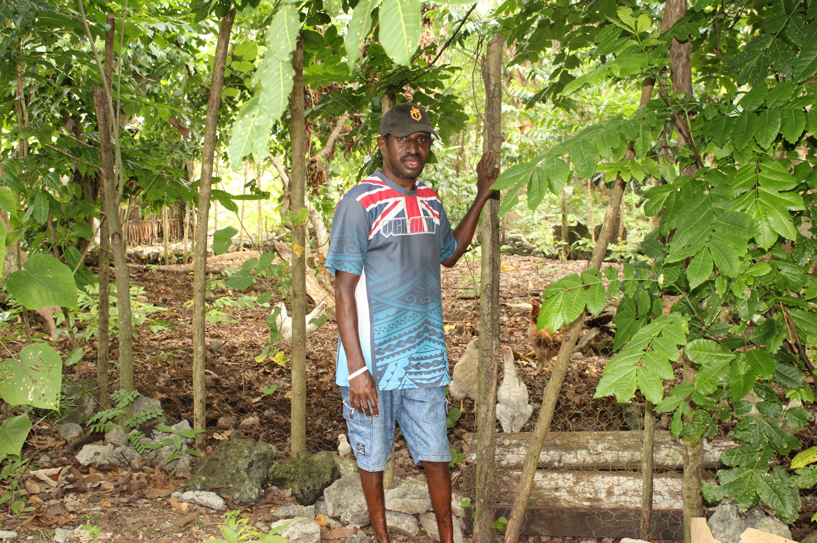
Photo: Mr. Nathan Roy, Farmer with intellectual disability, stands in front of his Chicken Pen, Vanuatu.
Source: Vanuatu Disability Promotion and Advocacy Association.

Story - From Flooded Fields to Future Plans: A Farmer’s Call for Inclusion and Support
My name is Mathias. I am a farmer of root crops, like cassava and sweet potatoes, and vegetables like cabbage. As a person with disability, I work with my wife who supports me with other tasks which I am not able to do by myself such as planting. I do the weeding, cleaning and other tasks which are easy for a blind person. I have been farming for three years.
I sell my farm produce to people around my community but I do get occasional customers who come to buy in large quantities for resale at the market. People know that I sell vegetables and root crops and they follow me to buy from our home garden. Vegetable and root farming is my main source of income and it has helped me to support my family and not rely on other people to help me. My children are in school and I support them from the money I earn from the sale of vegetables and root crops.
I have faced some challenges in my farming especially related to the bad weather condition in terms of flooding. Due to bad weather, some of the crops were washed away by flash flooding and I did not get much out of it when I sold what was left. My income was affected. When this happened, I called the responsible authorities to assist me, but they did not respond. When the flash floods happened again, I did not call anyone to help me because my previous experience was disappointing without any assistance from the authorities.
Today’s meeting on agribusiness has really opened my eyes and given me ideas on how I can sell my vegetables and root crops to expand my sales. I would like to expand my vegetable and root crops farming so that I can increase my income. What I do know is something I have learnt on my own but today’s meeting on agribusiness has given me more information on how I can manage my farm. I had my own ideas before, but now I have learnt new ones. I would like to be supported with capital and training on agribusiness so that I can learn how I can manage my farm. My dream is to expand my farming from root and crop vegetables to poultry. Poultry would be easy for me to manage as a person with disability.
Story shared by Mathias Wehi, Farmer, Solomon Islands

Sidebar – Government’s Role: Creating the Conditions for Inclusive Agribusiness
Inclusive agribusiness doesn’t happen in isolation. It requires an enabling policies, systemic change and legal environment, one that upholds the rights of persons with disabilities to work, participate, contributie, lead and thrive in agriculture.
Governments, as Signatories and/or State Parties to the United Nations Convention on the Rights of Persons with Disabilities (CRPD) have legal obligations to:
- Recognise and support the right to decent work for persons with disabilities, including in rural and agricultural contexts.
- Ensure that inclusive agricultural, employment, and climate policies explicitly address the needs and rights of persons with disabilities.
- Embed disability inclusion across national strategies for education, trade, social protection, and disaster risk reduction.
From Solomon Islands to Samoa, OPDs and farmers have consistently called for structural change. This includes:
- Policies and legislation that explicitly promote and protect people with disabilities on an equal basis with others.
- Government-led collaboration with OPDs as policy shapers, knowledge holders and implementers.
- Accessible, subsidised transport and road networks to enable market access and reduce isolation.
- Inclusive training and extension policies, ensuring sign language interpreters, peer mentors, and accessible materials are standard, not exceptional.
- Targeted grant and social protection schemes that support tools, start-up capital, and reasonable accommodations.
- Inclusion of people with disabilities in national producer registries, policy consultations, and agricultural boards.
"We need government support to gain recognition as farmers with disabilities.” - OPD member, Solomon Islands
"Incentives motivate us to keep farming and see the long-term benefit. Without this, it’s hard to continue." - Farmer with psychosocial disability, Solomon Islands
Practical action for governments:
- Use existing regional and global frameworks to guide inclusive agricultural policy and investment, such as the CRPD, the 2050 Strategy for the Blue Pacific Continent, Pacific Framework on the Rights of Persons with Disabilities, Jakarta Declaration on the Asian and Pacific Decade of Persons with Disabilities in Asia and the Pacific, Sendai Framework for Disaster Risk Reduction, and Sustainable Development Goals.
- Partner with OPDs to ensure that every policy, budget, and program considers disability inclusion not as a standalone issue, but as central to economic development, resilience, and food security.

Become an Employer of Choice for People with disabilities
Inclusive employment is a smart business strategy and a human right.
Agribusinesses that embrace inclusive employment benefit from a more diverse, loyal, and innovative workforce, and demonstrate leadership in ESG, B Corp, GEDSI, and CRPD compliance.
In the Pacific, consultations with people with disabilities, OPDs, and employers highlighted the following actions as essential. Please read this section together with Annex 1: Preconditions for Inclusion: A Checklist for Agribusinesses to Reflect and Act.

1. Commit to Inclusive Recruitment
- Partner with OPDs, vocational training centres, and disability networks to reach talent.
- Use inclusive language in job adverts and advertise in accessible formats (e.g. radio, social media, plain English flyers).
- Make efforts to reach women, youth, and persons with a range of disabilities, particularly those with deafblindness, psychosocial or intellectual disabilities, Deaf persons and those who may have acquired disability later in life who are often left out.
- In Fiji, an agribusiness shared how engaging an OPD helped identify candidates for seasonal roles and provide pre-placement preparation.
"People think persons with disabilities won't apply, but they will if the process is respectful and accessible." – OPD, Tonga

2. Make Workspaces Accessible
- Use universal design principles to ensure entrances, washrooms, and workstations are accessible.
- Simple modifications, like ramp installation, shaded rest areas, clear signage, and raised work surfaces, can make a big difference.
- One Tongan processor shared how rearranging sorting tables allowed a team member with limited mobility to continue contributing.

3. Fund Reasonable Accommodations
- Budget for assistive devices, interpreters, adapted tools, and flexible work arrangements.
- Collaborate with OPDs or service providers to source low-cost local adaptations.
‘Sometimes it's a $20 stool or a shift in roster times, that’s all someone needs.’ – OPD respondent, Fiji

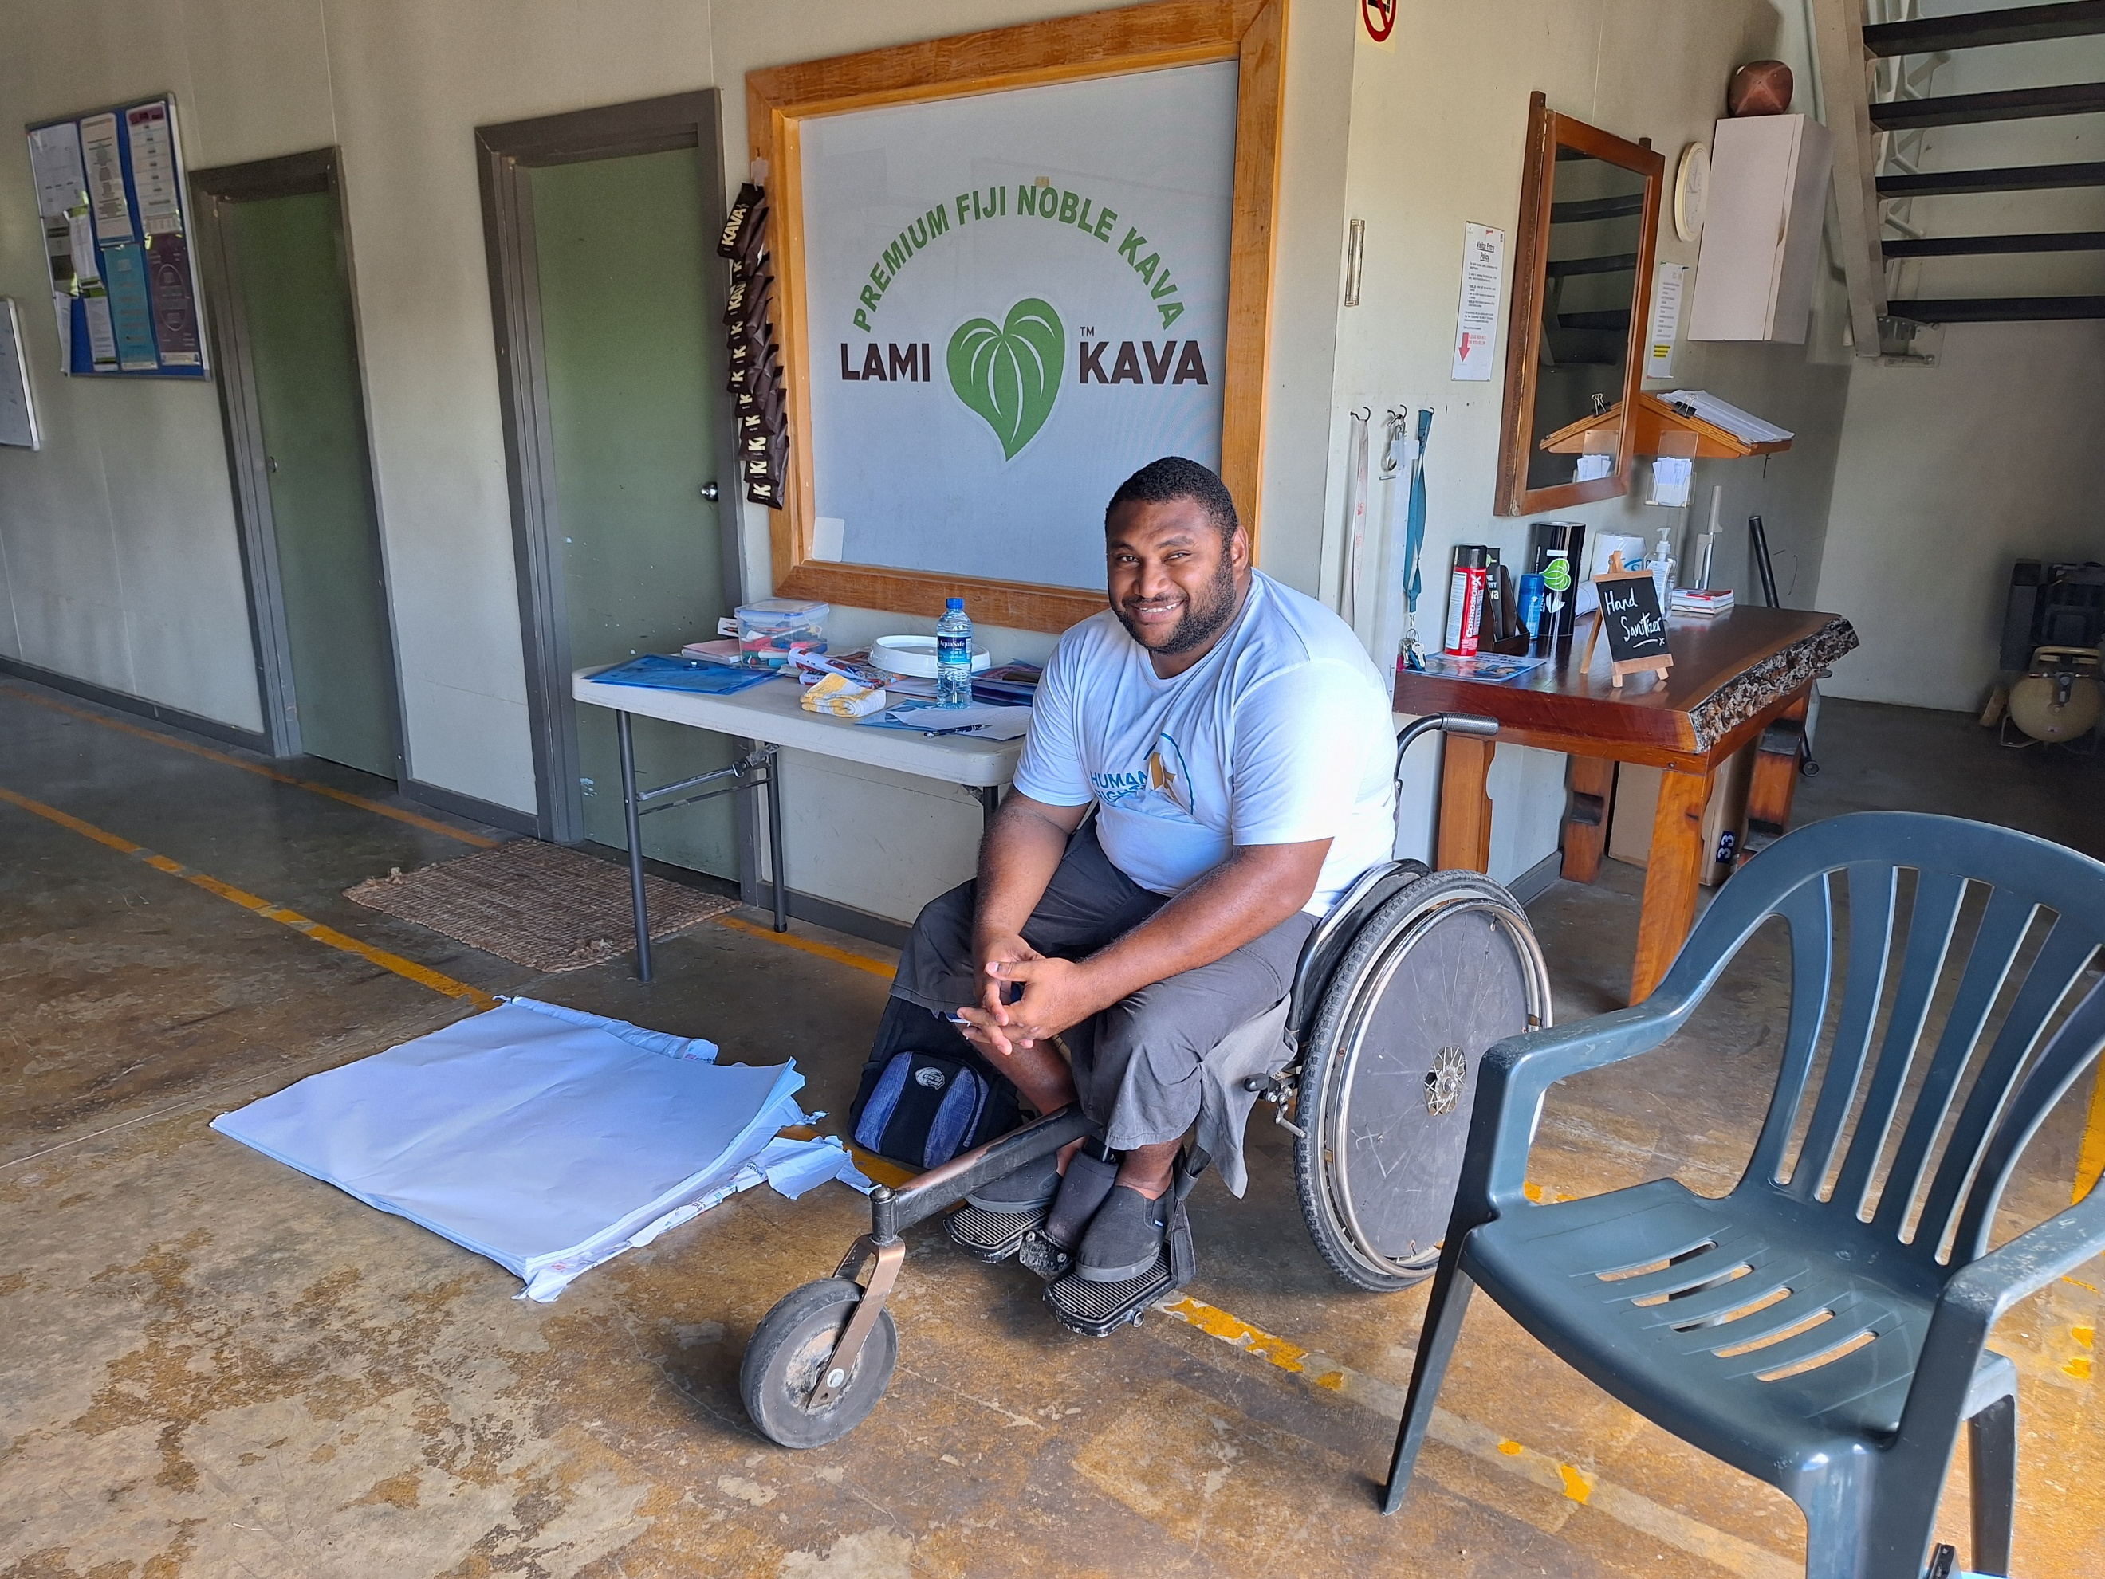

4. Offer Inclusive Training and Advancement
- Provide inductions, training, and safety briefings in multiple formats (e.g. visual, verbal, hands-on).
- Create opportunities for staff with disabilities to grow into leadership, supervision, or peer mentor roles.
- Facilitate disability awareness training for all staff and partners in partnership with OPDs.
- OPDs have supported the delivery of accessible training for people with different types of disabilities, ensuring content is visual, practical, relevant and community-based.
Photo: Antonio Tuvici, with the Pacific Disability Forum, co-facilitated disability sensitisation training for PHAMA Plus partner Lami Kava, in 2024. Source: PHAMA Plus
‘We adapt training so that everyone can understand, even if they can’t read or write. It’s about showing, not just telling.’ – OPD representative, Samoa

5. Foster a Respectful and Supportive Workplace Culture
- Hold disability awareness sessions and promote a culture where everyone feels respected and safe.
- Appoint a GEDSI focal point or inclusive workplace champion.
- Recognise the contributions and leadership of staff with disabilities as part of team and organisational achievements, including in staff meetings, newsletters, or social media.
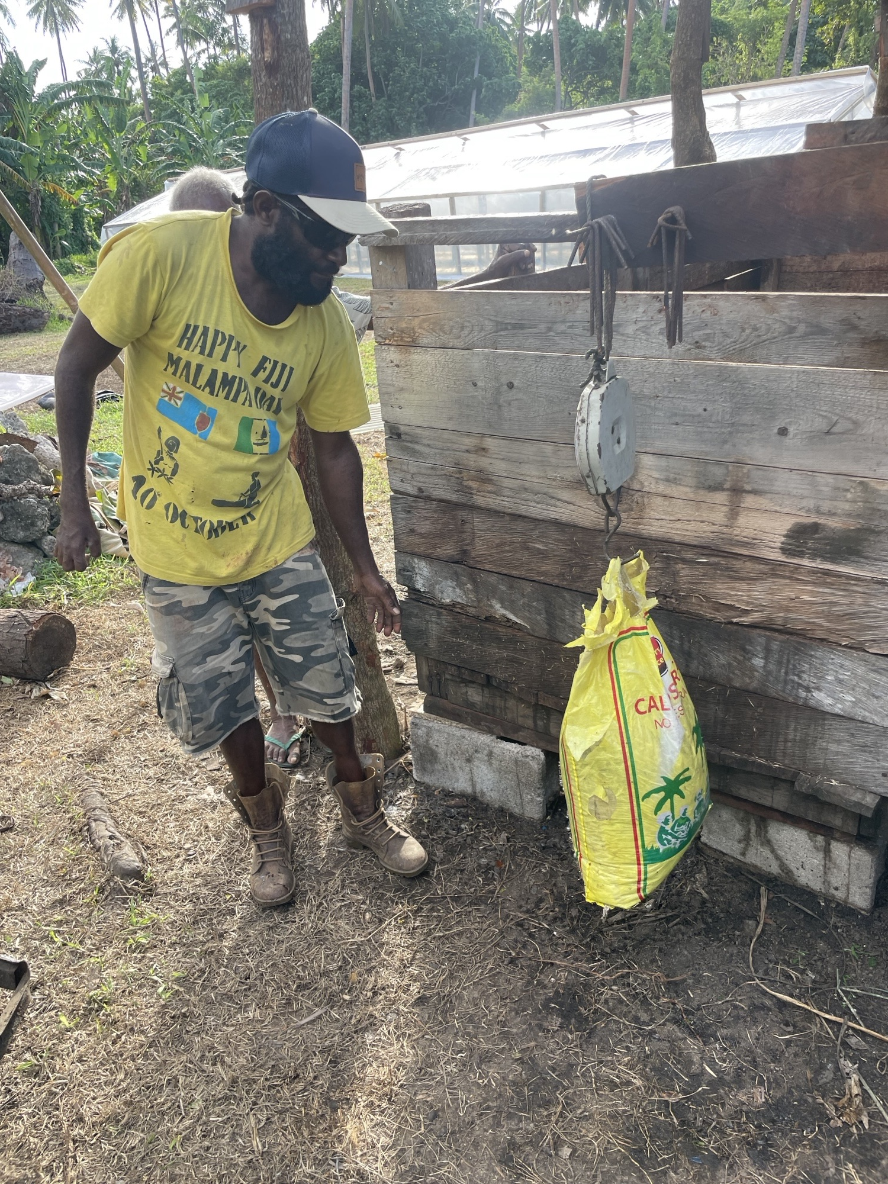
Photo: One of Gaston’s Lead farmers, Kendy Baktam, weighing a bag of cacoa beans before loading the beans into the cascading fermentation boxes. Source: Gaston Chocolat.

6. Track and Improve with Disability-Disaggregated Data
- Collect anonymous, voluntary data on staff disability status (self-identified).
- Use this to assess recruitment, retention, and promotion of people with disabilities.
- Partner with OPDs or statisticians to ensure ethical, safe practices.
‘Without data, we can’t show progress or gaps. It helps us advocate internally too. Agribusiness respondent, Fiji

Story – Vanuatu: Building Inclusion into the Business Model from Day One
Gaston Chocolat was founded with the intention to “do things differently.” From the outset, the company committed to employing over 60% of its staff from minority groups — including people with disabilities, women, and youth who did not complete their school education. “We wanted to prove that inclusion does not come at the cost of profitability,” said its founder.
In response to the growing outmigration of ni-Vanuatu through seasonal worker programs, Gaston Chocolat designed its operations to offer meaningful, community-based employment to those often left behind. The founder saw it not just as a business decision, but as a contribution to strengthening Vanuatu’s social and economic outcomes. He believes local businesses have a responsibility to make the country stronger.
Today, 77% of Gaston’s employees are from minority groups, and over 370 cocoa farmers — including farmers with disabilities — supply beans weekly from across the islands. The company employs people with both physical and psychosocial disabilities. Adaptations include redesigned fermentation systems, two-wheel wheelbarrows, lightweight harvesting containers, and accessible ramps. These changes were designed with and for employees, improving both inclusion and operational efficiency. Workers rotate through harvesting and pruning tasks in teams, reducing fatigue, lifting yields, and creating a stronger sense of value and belonging.
The workplace reflects Vanuatu’s communal values. Staff bring their children and other family members they are caring for when needed, they work close to home and work hours are flexible. Employees can grow within the business — even becoming shareholders.
Through the B Corp certification process, the team has learned how inclusive practices create lasting impact. “I want our way of doing business to be the norm — not the exception.”
Gaston Chocolat’s advice to other businesses: inclusion isn’t a cost — it’s a foundation for impact, satisfaction, and shared growth.

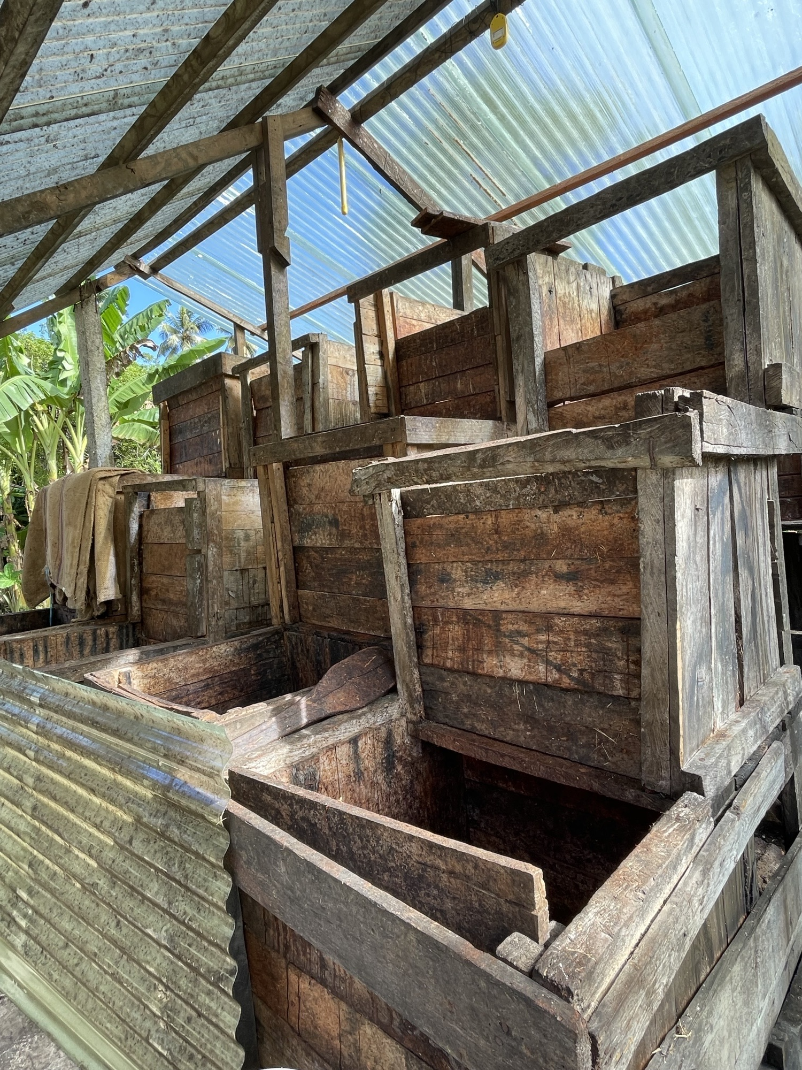

Photo: Cascading cocoa bean fermentation boxes developed with and for a farmer with physical disabilities to enable him to perform his duties efficiently and effectively.
Source: Gaston Chocolat.

Inclusion across the value chain
Pacific stakeholders explored the seven stages of the value chain commonly used by PHAMA Plus stakeholders. Practical actions that agribusinesses, OPDs and farmers with disabilities can take to improve inclusion, equity and accessibility in each stage were identified.
Below are some suggestions to support greater inclusion of people with disabilities across the value chain. Please refer to Annex 1 and Annex 2 for more also tips to inform your policy and practices across the value chain.

Story – Samoa: Leading from the Land, A Farmer’s Vision for Inclusive Agribusiness
A farmer from rural Samoa is showing what’s possible when experience, determination, and family support come together. After acquiring a physical disability in adulthood, he returned to farming, not only to support his family, but also to stay active and lead a meaningful life. Using his upper body strength, he manages crops, supervises planting and harvesting, and sells produce like bok choy and tomatoes at the Apia market.
His land is sloped, and without accessible infrastructure, he often transfers from his wheelchair directly onto the soil. “It’s tiring and I need long showers after farming,” he said. With the increasing heat from climate change, he has also suffered serious sunburns. “An accessible greenhouse would protect me and the vegetables. The sun is hotter than ever.”
He described how some NGOs visit only to “tick the box” and collect stories — without offering meaningful support. Despite clear plans and consistent effort, he’s been excluded from funding because eligibility often favours groups or larger farms. “There needs to be funding criteria for small farmers like me who are just trying to grow our business.”
He pays for help when he can and receives support from his son-in-law and a friend in agribusiness who sometimes contributes supplies. With accessible infrastructure and a small grant, he could scale his farm and help others. “I want to be a role model - not just in Samoa, but across the Pacific.”
With the right support, inclusive farming can thrive and farmers with disabilities can lead the way.

Sidebar - Important Note on Adapted Tools and Environments
There is no one-size-fits-all solution.
Effective and inclusive design must be developed with the person who will use it. This means involving persons with disabilities—especially farmers—in the design, decision-making, testing, and ongoing monitoring processes. Only they can determine what works best for them, their roles, environment, and goals.
Tools and environments must be regularly reviewed to ensure they remain fit for purpose as needs, roles, and contexts evolve.
Inclusion is not about giving something—it’s about working alongside the person to ensure what is provided truly enables independence, dignity, and productivity.

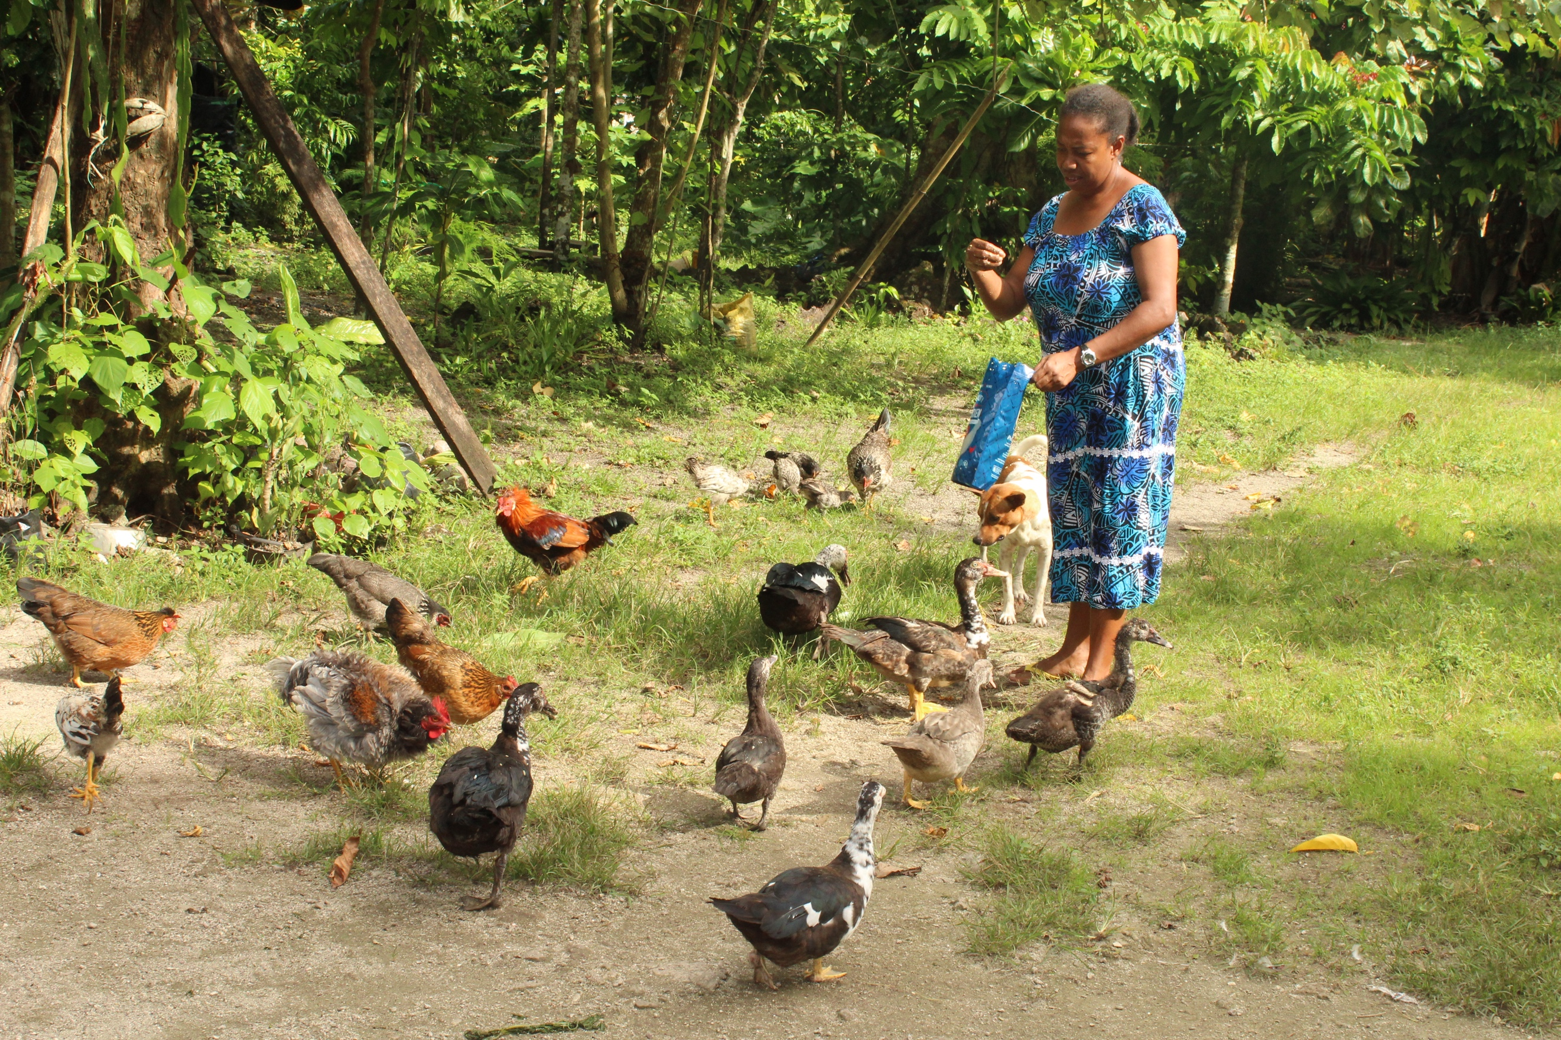
Photo: Mrs Marie Elina Silas, Hard of Hearing Farmer, stands with her dog amongst her chickens and ducks to feed them, Vanuatu.
Source: Vanuatu Disability Promotion and Advocacy Association.

Table: Inclusion across the value chain
Table description: This table is divided into four columns. Column one lists the value chain stages. Each value chain stage is listed in its own row. Column two provides actions for agribusinesses in each value chain stage, column three lists actions for OPDs in each value chain stage and column four lists actions farmers with disabilities in each value chain stage. The actions reflect that which can make agribusiness and agricultural activities more inclusive of people with disabilities.

Value chain stage | Agribusiness actions | OPD actions | Farmer with Disabilities’ actions
- Inputs and Services  This stage includes provision of seeds, fertilisers, tools, financing, and technical advice. | - Offer inclusive access to quality seeds, tools, equipment and fertilisers.  - Provide flexible payment options or small starter packs.  - Partner with OPDs to identify access barriers and adapt service delivery.  - Ensure persons with disabilities are actively registered and supported through government agricultural schemes and input distributions.  - Ensure access to tools, raised garden beds, adaptive equipment and nearby land to reduce mobility and transport barriers.  - Link farmers with disabilities and their families to relevant government and donor funded programs (e.g. business or financial literacy training). | - Map accessibility of input suppliers and identify gaps.  - Raise awareness among suppliers about diverse needs of farmers with disabilities.  - Facilitate training or linkages with local agricultural officers.  “We adapt training so that everyone can understand, even if they can’t read or write. It’s about showing, not just telling.” – OPD, Samoa | - Engage in group purchasing or cooperatives to access better deals.  - Share feedback on challenges with tools or service access.  - Request training or demonstrations adapted to your needs.  "I received seedlings from programs... Business is right at home and makes it easy to work." – Farmer, Samoa
- Production  This stage includes farming, cultivation, and harvesting. | - Ensure flexible roles that accommodate different capacities.  - Support accessible workspaces and pathways.  - Incorporate farmers with disabilities in training and field demonstrations.  - Encourage partnerships with local government agriculture offices to co-design accessible farming demonstrations with OPDs and farmers with disabilities. | - Provide peer support or technical advice.  - Advocate for access to land and inclusion in rural programs.  - Offer disability awareness training to agricultural extension workers.  ‘We are still farmers. We just need a chance to do things our way and with support.’ OPD Member, Tonga | - Adopt accessible practices like raised beds or mobile containers.  - Build peer networks for shared labour or toungaue (communal work).  - Participate in trials and feedback on adaptive production techniques.
- Post-Harvest Handling  This stage includes storage, grading, and packaging. | - Provide packaging tools that are easy to use and require less physical strain.  - Adjust post-harvest stations to be physically accessible.  - Ensure inclusive and accessible sorting and grading processes. Find solutions with OPDs and people with disabilities.  - Provide visual signage and simplified pictorial instructions on sorting, grading, and packing processes for farmers with intellectual or psychosocial disabilities. | - Demonstrate adapted post-harvest techniques.  - Promote inclusion in group post-harvest activities or cooperatives.  - Support local innovation and training around product preservation. | - Use home-based or near-home solutions for drying and packing.  - Coordinate with families or neighbours for shared processing.  - Seek advice on quality standards and simple compliance methods.  ‘I am part of the different stages of making the Cocoa Samoa for selling. From roasting to packing. We work at the market.’ Farmer, Samoa
- Processing  This stage includes value addition, transformation of raw products. | - Provide shared or mobile processing tools.  - Include disability-led enterprises in value-addition supply chains.  - Make training spaces and equipment accessible and safe.  - Link home-based processors with cooperatives for collective branding, access to labelling materials, and compliance knowledge. | - Connect entrepreneurs with disabilities to processing support.  - Promote cooperative models for small-scale inclusive processing.  - Assist with advice about labelling, branding, and packaging accessibility. | - Explore roasting, grinding, or bottling products at home.  - Participate in branding and marketing workshops.  - Collaborate with others to increase scale and shelf life.
- Marketing and Distribution  This stage includes transport, sales, and local markets. | - Promote visibility of inclusive businesses in marketplaces and facilitate access to village, municipal, or tourist markets.  - Provide accessible stalls or coordinate home-based distribution.  - Involve people with disabilities in logistics or communications roles.  - Recognise informal market actors with disabilities and support their visibility and rights as legitimate producers and sellers. | - Support accessible digital marketing training and visual content creation.  - Facilitate access to village, municipal, or tourist markets.  - Advise on inclusive branding and customer engagement. | - Use social media or family networks to sell produce.  - Request accessible space in markets or co-selling with others.  - Highlight inclusive values in your story or packaging.
- Market Access and Trade  This stage includes export processes, meeting standards, and certifications. | - Include OPDs and farmers with disabilities in export or compliance training.  - Offer mentoring on business growth or meeting trade standards.  - Link farmers with disabilities with certification bodies to support accessible quality checks.  - Support farmers to build social identity and be recognised in the community as part of the market.  - Ensure consultation with people with disabilities when national export standards and farmer registries are being designed. | - Advocate for inclusive trade platforms and networks.  - Support participation in farmer-to-buyer exchanges or showcases.  - Co-design and co-facilitate training on pricing, contracts, and negotiation. | - Build partnerships with local buyers or traders.  - Engage in co-branding to access bigger markets.  - Learn basic records and compliance needs for scale.  ‘I want to build a factory to increase my products and sell to overseas market.’ Farmer, Fiji
- End Markets  This stage includes domestic and international consumers and buyers. | - Ensure customer spaces and packaging are accessible.  - Recognise people with disabilities as both suppliers and consumers.  - Include diverse rights-based stories in brand communications.  - Support relationships between farmers with disabilities and local restaurants, schools, or church-based buyers to create inclusive micro-contracts. | - Raise awareness about accessible product design and services.  - Support farmers with disabilities to conduct market research.  - Collaborate with consumer groups to promote inclusive values.  ‘Some of the group members purchased from people with disabilities.’ Samoa OPD representative | - Request feedback from buyers on packaging and quality.  - Use customer insights to adapt products or formats.  - Promote inclusive messaging on social media or labels.

Conclusion
“I want to be a big farmer in my community. I want access to big farming machines once the road to my village is built, employ youth in my village, and one day export to overseas markets.” - Peniasi Dobui, Farmer, Fiji
Inclusive agribusiness is already happening across the Pacific, but it must become the norm, not the exception.
Farmers with disabilities are contributing, innovating, and leading in every stage of the value chain. OPDs are partnering with agribusinesses, delivering training, and shaping inclusive systems from the ground up.
Across the region, agribusinesses are stepping forward – employing people with disabilities, adapting workspaces, seeking guidance, and showing genuine commitment to being agents of inclusive change.
This guidance note captures just a few of the many examples shared through consultations across the region. The actions outlined in this document are practical, achievable, and grounded in Pacific realities.
Whether you are an agribusiness, an OPD, a government partner, or a donor, the path to inclusion is clearer when walked together.
Equitable inclusion recognises that people with disabilities are not a single group. Farmers and people with different types of disabilities, gender identities, and life experiences must all be seen, supported, and included in shaping the future of agribusiness.
Start with partnership. Act with purpose. Centre the voices and rights of people with disabilities.
Together, we can grow a more inclusive, resilient, and equitable agricultural future for all.

Annex 1: Preconditions for Inclusion - A Checklist for Agribusiness to Reflect and Act
This tool was designed by the Strategic Development Group, on behalf of PHAMA Plus to support agribusinesses reflect on how they can apply the six preconditions for disability inclusion across their agribusiness policy, systems, processes and practice. This tool aligns with the Pacific Disability Forum’s Precondition for Inclusion Framework.
This tool is not comprehensive. It is designed to help agribusinesses to start thinking about how to ensure the rights, equity and inclusion of people with disabilities.
Precondition & Explanation | Prompts for Reflection and Action
1. Non-Discrimination  Removing legal, policy, systemic, social, and attitudinal barriers that exclude people with disabilities from opportunities. This includes reasonable accommodation, inclusive hiring, and representation. | - Are you familiar with the Convention on the Rights of Persons with Disabilities and your national disability policy?  - Have you considered the full range of roles your agribusiness can play to support inclusion—such as buyer, mentor, connector, or advocate—not just employer?  - Are people with disabilities represented across roles or departments in your business?  - Are people with disabilities represented in your board or other decision-making bodies?  - Do you collect disability, gender, age, location disaggregated data?  - Are hiring practices open, flexible, and recognise the different roles people with diverse abilities can play across the agribusiness (e.g. farming, team leading, sorting, sales, admin)?  - Do you offer equal pay for equal work and flexible work options?  - Have you reviewed internal policies or informal practices for bias which favours people without disability?  - Have you reviewed your policies and practices to ensure accessibility and inclusion of people with diverse disabilities, genders, age, locations on an equal basis with others?  - Have you asked OPDs to review your practices or share what exclusion might look like in your context?  - Have your staff received disability awareness and inclusion training?  - Have you budgeted for technical advice, reasonable accommodations and support to OPDs to support you to become and inclusive agribusiness?  - Are you providing fair and inclusive opportunities for people with disabilities to contribute beyond employment (e.g. as suppliers, buyers, entrepreneurs, or partners)?  - Are people with disabilities supported or encouraged to take on leadership, management, or enterprise ownership roles?
2. Accessibility  Ensuring environments, information, transport, and communications are accessible. Accessibility is the foundation that enables participation in agribusiness and community life. | - Are your offices, farm sites, training areas, and facilities physically accessible?  - Is information available in formats everyone can use (e.g. pictures, plain language, large print)?  - Are you using accessible communication (e.g. avoiding jargon, offering alternatives to written content, using sign language interpreters where required)?  - Have you asked OPDs to conduct an access audit of your facilities, information and communication?  - Do you consider transport accessibility when you have training or meetings? (e.g. do you provide transport, or cover costs of transport, or carry out the activity close to farmers with disabilities to ensure participation)  - Do you ask all participants for their accessibility requirements before any event or activity?  - Do you target people with disabilities in your information sharing and communication, making sure they receive information?  - Have you budgeted for accessibility-related supports (e.g. interpretation, transport, assistants, accessible venues)?  - Have you considered accessibility in your climate and disaster resilience activities?
3. Assistive Technology  Providing access to essential assistive products and services that support independence, mobility, communication, and productivity in farming and business. | - Have you spoken to farmers or workers about tools that could improve their independence and safety?  - Do you ask farmers with disabilities what type of modifications to tools and environment may help them succeed? Dialogue can help identify the most appropriate modifications that can be made.  - Are tools available in different sizes or weights?  - Do you know where to refer someone for assistive devices (e.g. glasses, hearing aids, crutches, wheelchairs, white canes)? OPDs can be a source of information.  - Are there community members or businesses you can partner with to help modify tools for people with disabilities? Consider if any people with disabilities may have the skills to modify or develop tools.  - Can existing tools or workstations be adapted with low-cost modifications?  - Have you budgeted for costs to adapt tools and resources?
4. Community-Based Inclusive Development (CBID)  Mobilising community resources and networks to reach and support people with disabilities in rural and remote areas, ensuring inclusive development that leaves no one behind. | - Are you working with community leaders, groups, churches, or OPDs to reach farmers with disabilities?  - Have you invited people with disabilities to trainings or farmer meetings or networks?  - Are you supporting inclusion in rural or outer island areas?  - Do your programs link people to social, financial, or market support in their communities?  - Do you support farmers with disabilities to engage in village/community development planning and budgeting processes?  - Do you work with local networks or cooperatives to identify and support suppliers with disabilities or disability-led agribusinesses?  - Do your programs help connect people with disabilities to buyers, training providers, or community-based enterprise initiatives?  - Have you explored how local traditional knowledge and practices for farming, climate and disaster resilience ensure inclusion and accessibility in the community?  - Have you explored the role of traditional practices (e.g., communal labour, kerekere, Tou Ngaue) in enabling or limiting access for people with disabilities?  - Have you budgeted for accessibility-related supports (e.g. interpretation, transport, assistants, accessible venues)?
5. Social Protection  Addressing the additional costs of disability through targeted allowances, disaster-responsive payments, and inclusive benefit schemes that support participation and resilience. | - Do you understand the extra costs people with disabilities face (e.g. transport, time, caregiving)?  - Are you advocating for inclusive access to public subsidies or donor programs?  - Can your business help link people with disabilities to support programs or government schemes, including to support reasonable accommodations they need for farming?  - If you partner with government schemes or donor programs, ask how people with disabilities can benefit from subsidies, climate financing or disaster relief payments?  - Have you discussed inclusive pay or subsidies with government or donor partners?
6. Support Services  Ensuring availability of personal assistance, peer support, sign language interpretation, and other human supports necessary for people with disabilities to fully engage in economic and community life. | - Do your programs allow for support people (e.g. family, peer mentors, interpreters) to join when needed?  - Have you connected with local NGOs or OPDs to source support services?  - Are business meetings, partnerships, and supplier forums welcoming of support persons (e.g. interpreters, assistants, peer supporters)?  - Have you considered ways to help sustain inclusive initiatives over time, such as mentoring or peer networks?  - Have you budgeted for accessibility-related supports (e.g. interpretation, transport, support persons)?

Annex 2: Practical Examples of Preconditions for Inclusion in Action
The table below shares the six preconditions and their explanation in column one. Column two provides some examples of practical actions that agribusinesses can take to ensure rights, equity and inclusion of people with disabilities.
The list of examples is not exhaustive. There are many and varied actions that can be taken. Consult with OPDs and farmers with disabilities to identify inclusive and accessible actions appropriate for your context and the experiences of people with disabilities in your community.

Precondition & Explanation | Examples of practical actions
1. Non-Discrimination  Removing legal, policy, systemic, social, and attitudinal barriers that exclude persons with disabilities from opportunities. This includes reasonable accommodation, inclusive hiring, and representation | - From the boardroom to the packing shed, promote inclusive values. Appoint disability ambassadors, celebrate success stories, and model inclusive leadership.  - Create inclusive policies,including policy for reasonable accommodations.  - Review hiring practices to make sure you are not unintentionally excluding someone who could work in across your business e.g. management, sorting, sales, or admin roles.  - Challenge discrminatory assumptions like “people with disabilities can’t farm” or “people with disabilities can’t make decisions about their own money”, andrecognise rights based and inclusive behavious and actions.  - Help advocacte for anti discrminatory policies  - Share stories of farmers with disabilities who succeed, and support inclusive roles across gender, age, and disability.  - Offer equal pay for equal work, and allow flexible roles for people with diverse disabilities.  - Partner with Organisations of Persons with Disabilities (OPDs) to conduct disability inclusion awareness training.  - Seek out farmers with disabilities to contribute to your supply chain.  - Include a non-discrimination clause in contracts with suppliers and partners.  - Appoint a workplace inclusion focal point or mentor for new employees with disabilities.  - Ensure women with disabilities have equal access to leadership roles or cooperative memberships  - Use radio or church announcements to dispel myths about disability and farming  - Ensure consultation processes (e.g. around farm upgrades or market shifts) invite feedback from people with disabilities.
2. Accessibility  Ensuring environments, information, transport, and communications are accessible. Accessibility is the foundation that enables participation in agribusiness and community life. | - Ensure farm facilities, packhouses, offices, and field sites are reachable and usable—for example, installing simple ramps, shade for waiting areas, help make land accessible, provide or help build raised garden beds, ensure tactile markers can be created for people with vision impairment to help identify crops or picture markers for people with intellectual disabilities.  - Use large-font posters at input shops. Use plain language or picture-based signs for training material or for calendar charts that show best times to plant crops.  - Co-design farm layouts or facility upgrades with people with disabilities and OPDs.  - Provide portable seating, mats, or shaded spaces for farmers during training.  - Use WhatsApp voice notes or short videos to share information for those with limited literacy.  - Hire OPDs to conduct accessibility audits and include people with disabilities in accessibility audits of markets or transport systems.  - Offer flexible meeting times or locations to ensure participation of persons with disabilities and their families.  - If using or creating digital platforms, ensure people with disabilities are included in the design and ongoing testing of its accessibility.  - Make sure farmers with disabilities can access training, seeds, finance, and market information. For example, bring training closer to villages or offer it in more than one format.  - Create grant mechanisms that reduce start-up risk and provide flexible financing tools.  - (Re)Build bridges and subsidise transport, or help advocate to relevant authorities for this critical accessible infrastructure that creates a barrier for farmers with disabilities.
3. Assistive Technology (AT)  Providing access to essential assistive products and services that support independence, mobility, communication, and productivity in farming and business. | - Adapt tools to suit different users—for example, modified hoes or raised beds for farmers with mobility disabilities, long reach weeders, vibration-based emergency alert system for farm hazards and locking systems, solar motion sensor lights (deaf-accessible). Websites like Disability Horizons, Instructables and Disability Work Consulting offer various ideas for adapted gardening and farming tools that may help with ideas.  - Connect with local services to source or fund assistive devices like hearing aids or mobility devices.  - Trial inclusive equipment during community demonstration days.  - Partner with technical/vocational schools to co-develop and prototype adaptive tools.  - Create a “tool library” or shared AT service for smallholder farmers.  - Explore off-road mobility and adaptive tools to help increase productivity, especially during the Pacific rainy season.  - Connect with ministries of health and education, OPDs and disability service providers to support access to rehabilitation and assistive technologies/devices.  - Link AT access to grant applications or Micro, Small, and Medium Enterprises start-up kits.  - Ensure budgets allow for reasonable accommodations to pay for assistive technology for farming and agribusinesses.
4. Support Services  Ensuring availability of personal assistance, peer support, sign language interpretation, and other human supports necessary for people with disabilities to fully engage in in farming, agribusiness, economic and community life | - If someone needs a sign language interpreter or peer support during training, try to source it locally. Check if an OPD or local NGO can assist.  - Respect the need for carers or family support in field or processing work and provide training and tools for them alongside the farmers with disabilities.  - Recognise spouses, neighbours, and family as contributors in inclusive agribusiness systems. Support OPDs and NGOs to link these family support networks with practical resources, tools, and services from government and donor-funded programs where they exist.  - Offer a buddy or mentor system for farmers with disabilities (e.g. inclusive farmer-to-farmer extension).  - Include family in mentoring models (e.g. Family Farm Teams, peer-to-peer outreach)  - Include a budget line or eligibility category for support services including informal/family co-farmers and for support persons in training and field activities.  - Provide local language materials with audio narration or sign language insert videos.  - Work with OPDs to coordinate transport and logistics for persons needing mobility or communication support. Remunerate OPDs for their time and effort to cooridnate as well as for support service costs/fees.  - Ensure referral mechanisms exist when people disclose gender based violence, mental health needs, or personal care gaps.
5. Community-Based Inclusive Development (CBID)  Mobilising community resources and networks to reach and support people with disabilities in rural and remote areas, ensuring inclusive development that leaves no one behind. | - Work with local leaders, churches, women's groups, and OPDs to find and support farmers with disabilities in the community.  - Support farmers with disabilities to join farmer networks, associations, cooperatives or communities of practice.  - Link farmers with disabilities with finance or market programs you’re involved in.  - Invite OPDs or representatives of farmers with disabilities to planning meetings, training or consultation workshops. Ask: “What’s working? What’s missing?”  - Host community-based inclusion mapping days with OPDs and service providers.  - Include CBID workers or community outreach officers in your business extension/technical team.  - Create roles for people with disabilities in farmer groups as outreach champions or peer trainers.  - Offer farm visits and consultations in community locations familiar and comfortable to people with disabilities (e.g. churches, schools, markets).  - Invest in radio or village-based storytelling to explain agribusiness opportunities.
6. Social Protection  Addressing the additional costs of disability through targeted allowances, disaster-responsive payments, and inclusive benefit schemes that support participation and resilience. | - Advocate for fair pay that reflects additional costs (like transport, support persons, or caregiving).  - If you partner with government schemes or donor programs, ask how people with disabilities can benefit from subsidies or disaster relief payments.  - Advocate for business and government subsidies that offset cost of accessibility upgrades or accommodations.  - Support employee or farmer access to disability allowances or ID verification to access payments.  - Identify whether people with disabilities are eligible for business recovery grants or climate insurance.  - Share information on how to register for or renew social welfare support during disasters.  - Include carer or family support payments in your human resource policies or pilot programs.

Registration for consultations was voluntary. While there were 100+ contributors across the consultations, 79 chose to register. Of the 79 contributors: - 77% were persons with disabilities - including people with physical disabilities (44%), people who are blind/ or partially sighted (22%), Deaf persons (10%), people with psychosocial disabilities (6%), people with intellectual disabilities (3%), hard of hearing persons (3%), people with epilepsy (2%), and people with disabilities not listed (7%). An additional 10% were family members of persons with disabilities. - Stakeholder groups included OPD staff and members (56%), farmers (52%), non-OPD persons with disabilities (9%), PHAMA Plus agribusiness partners (8%), people from the private sector (4%), NGOs (3%), and government representatives (1%). - Gender identity: 68% men and 32% women. - Age: Most participants were aged 40–49 (36%), followed by 50–59 (25%), 30–39 (18%), 18–29 (12%), and 60+ (9%). - Country representation included Fiji (31%), Samoa (27%), Tonga (22%), Vanuatu (12%), and Solomon Islands (8%). - Residence: urban (61%), rural (29%), and outer islands (10%). - Intersectional identities included indigenous persons with disabilities (39%), women and girls with disabilities (23%), older persons with disabilities (10%), people from ethnic minorities (10%), and youth with disabilities (7%). - Farmers in the consultations were engaged in a wide range of production, including root crops (e.g. cassava, dalo, taro, yam, sweet potato, kumala), vegetables (e.g. bele, cabbage, tomato, chilli, eggplant), fruits (e.g. banana, pineapple, coconut), livestock (e.g. pigs, goats, chickens, ducks), spices and herbs (e.g. ginger), value-added goods (e.g. jam, ginger products), and cash crops (e.g. kava, cocoa).
PHAMA Plus GEDSI Strategy Summary (2023)
UNESCAP (2022). Disability-Inclusive Development in Asia and the Pacific.
UNESCAP, 2020, Employment of Persons with Disabilities in Asia and the Pacific: Trends, Strategies and Policy Recommendations No. 2020/13. The Indonesia’s National Labour Force Survey (Sakernas), 2020, found persons with disabilities were 1.5 times more likely to be self-employed than persons without disabilities.
Pacific Community, Non-Communicable Diseases Prevention and Control Programme, accessed 23 May 2025.
A Certified B Corporation (B Corp) is a for-profit company that has been certified by B Lab as meeting high standards of social and environmental performance, accountability, and transparency. The "B" stands for "benefit for all," signifying a commitment to balancing profit with purpose and creating a more inclusive and sustainable economy.
This refers to the identity verification process required by financial institutions to confirm a customer’s identity before opening an account or accessing services. Traditional KYC can be a barrier for persons with disabilities if documentation requirements are strict or the process is not accessible.
These are financial service providers—often operating at community level—that offer small loans, savings, insurance, and other services to individuals or small enterprises who may not have access to traditional banking. MFIs can play a critical role in inclusive agribusiness finance.

